Pre-Reading

His Routine
The first word 其实 (qi2shi2) means "in fact or actually." So here in the beginning of this passage, the speaker is adding additional information about his father who was introduced in the second reading as a thief. Now we find out that his real job is a 保洁 (bao3jie2) "janitor." 保 means to preserve or protect and 洁 means "clean." Thus, janitor literally means someone who preserves cleanliness. 他和我妈妈, the second character 和 （he2） means "and.” So this construction means "he and my mother". 地方 (di4fang1) means place and 上班 (shang4ban1) means “to go to work.” In the last reading, you learned that 工作 means "to work," The main difference here is that 工作 can be a noun or a verb, where as 上班 only functions as a verb. 上 you saw was used in the last text by describing going to the university, here it is for work, it can also be used for things like 上车(shang4 che1) which is get in the car or 上网 (shang4wang3) which literally means get on the net or surf the net. In the next sentence we see the word 每天 (mei2tian1) which is divided into two characters the first is 每 which means each and the second 天 which is sky or day. So 每天 can be understood as every day. The following words are related to the time of day. 早上 (zao3shang) which is morning and 晚上 （wan3shang）which is night or late evening. These two words you’ll want to compare with the words 上午 (shang4wu3) which is before noon and 下午 (xia4wu3) is after noon， where as 午（wu3） means noon and 上 and 下 indicate before and after, where as 早上 and 晚上 would signify early morning and late evening. The next word that we need to pay attention to is 努力 (nu3li4). The first character 努 which means to strive, notice how this character has three parts. The second character 力 simply means “strength.”So together these characters mean “to work hard.” The next word is 开始 (kai1shi3), the first character 开, means to turn on or to activate something, whereas the 始 means to begin. Pay attention to the two components of 始， the left side is a woman女 and the right side is a platform 台. Paying attention to these radicals will help you remember not only how to write the character, but also how to remember the meaning. See if you can make a relationship between the woman and the platform and the meaning. The next word literally means east and west, the word 东西 (dong1xi1) means things, the idea is that things come from both the east and the west. The last word was hinted to in the last reading but we will look at it again. 回家 (hui2jia1), the first character 回 means to return, if you can imagine the character as a circle that is always returning to the beginning, then it will be easier to remember. So 回家 just means to return home. In this lesson you saw many different uses of 上 don’t try to pin down one meaning for this character, just accept that its meaning can change a little depending on what it is paired with, many characters are like this.
Story Character Count = 50

Vocabulary/Writing
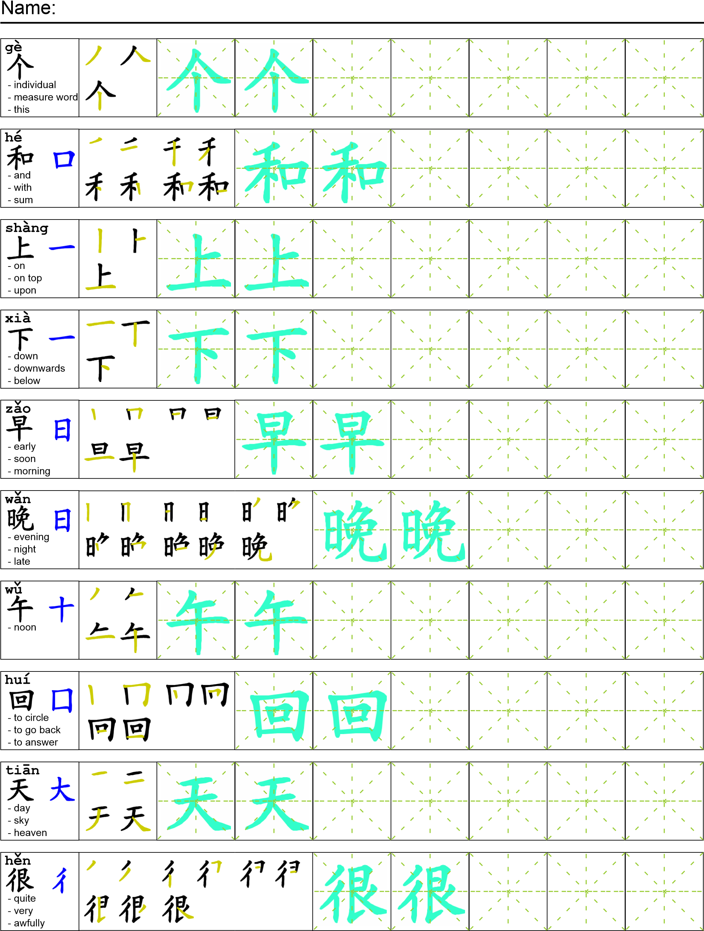
Reading

其实我爸爸是一个保洁。他和我妈妈在一个地方上班。他每天早上去上班，上午很努力地工作。下午他开始偷东西，晚上回家。

Task Completion

Once all tasks are complete turn the assignment in to collect the points for the project.
Task 1: Trace the vocabulary and copy the story into your notebook.

Task 2: Answer Comprehension Questions

Task 3: Write the Pinyin for the Reading

Task 4: Translate the Reading into English

Task 5: Record yourself reading the passage.

Comprehension Questions
- What does the author’s father do in the morning? _____________________________________
- What does the author’s father do in the afternoon? ____________________________________
- What does the author’s father do in the evening? ______________________________________
- What is the difference between 上班 and 工作？_______________________________________
- Tell me two uses of the character 上. _________________________________________________

